SLEEP CYCLE PRODUCTIVITY
ANALYSIS

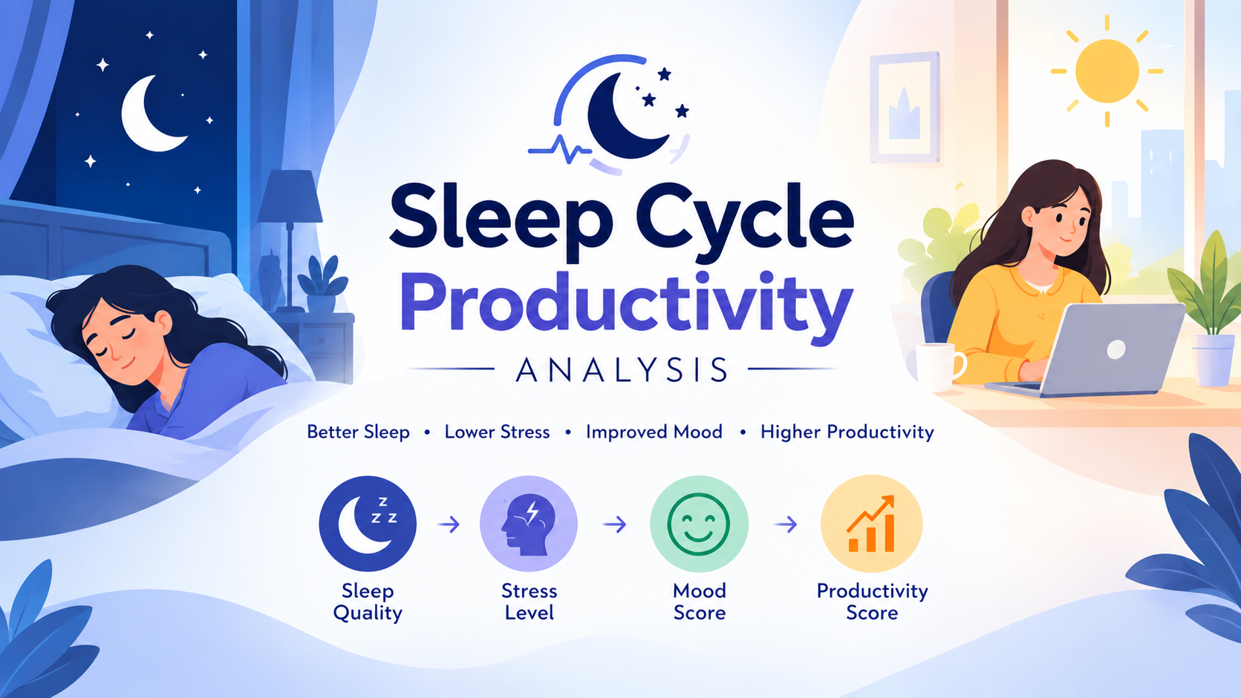

BY
GREESHMA R KRISHNAN

INTRODUCTION
Sleep plays an important role in maintaining physical well-being, mental alertness, mood, and daily performance. Variations in sleep duration and quality, along with lifestyle factors such as exercise, caffeine consumption, screen exposure before bedtime, and working hours, can be associated with changes in stress levels, mood, and productivity. This project analysis 5,000 records and 18 attributes covering sleep patterns, sleep quality, exercise, caffeine intake, screen time, work hours, mood, stress, and productivity. The objective is to identify patterns and relationships between sleep, lifestyle factors, and daily performance.
The raw dataset was cleaned and prepared using Python to improve data quality and consistency, followed by Exploratory Data Analysis (EDA) to identify meaningful patterns. The prepared data is then used to develop an interactive Power BI dashboard featuring key performance indicators, trends, comparisons, and insights.
Project Flow: Raw Data → Python Data Cleaning → EDA → Data Preparation → Power BI Dashboard → Insights

AIM
The primary aim of this project is to explore and derive meaningful insights from the Sleep Cycle Productivity dataset using Python, Exploratory Data Analysis (EDA), and Power BI. The analysis focuses on understanding sleep patterns, lifestyle factors, well-being, and their association with productivity. Specifically, the analysis aims to:
- Analyze Sleep Patterns: Examine sleep duration, sleep quality, and sleep timing to identify common patterns.
- Evaluate Lifestyle Factors: Analyze the impact of exercise, caffeine consumption, screen time, and working hours on sleep and productivity.
- Identify Relationships and Trends: Discover meaningful relationships between sleep, mood, stress levels, and productivity scores.
- Support Data-Driven Insights: Present key findings through an interactive Power BI dashboard to support better understanding of factors associated with daily productivity and well-being.
This analysis provides a practical approach to understanding sleep and lifestyle data while demonstrating the use of Python, EDA, and Power BI for real-world data analysis and visualization.

OBJECTIVES

1. Data Collection:
The Sleep Cycle Productivity dataset consists of 5,000 records and 18 attributes covering demographic details, sleep patterns, lifestyle habits, well-being, and productivity. Key variables include age, gender, sleep duration and quality, exercise, caffeine intake, screen time before bed, work hours, mood, stress, and productivity scores. The dataset provides a foundation for studying the relationship between sleep habits, lifestyle factors, and productivity.

2. Data Cleaning and Preprocessing:
The raw dataset was cleaned and preprocessed using Python to ensure data accuracy and consistency. The process included inspecting the dataset structure and data types, identifying missing and duplicate records, checking inconsistent or invalid values, standardizing categorical variables, validating numerical fields, and reviewing time-based and calculated variables. The cleaned dataset was then prepared for further analysis and visualization.

3. Exploratory Data Analysis (EDA):
EDA was performed using Python to identify important patterns, distributions, and relationships within the dataset. The analysis examined sleep duration, sleep quality, sleep status, exercise, caffeine intake, screen exposure, work hours, mood, stress, and productivity. Comparative and grouped analysis was conducted to understand relationships such as stress by sleep status, productivity by sleep status and screen exposure, and sleep quality across gender and caffeine intake levels.

4. Data Visualization and Dashboard Development:
The cleaned dataset was analyzed in Power BI to develop an interactive dashboard. KPIs, charts, and slicers were used to highlight key relationships between sleep, lifestyle, well-being, and productivity.

DATA OVERVIEW

Column name | Data Type
Date | datetime64[ns
Person_ID | int64
Age | int64
Gender | object
Sleep Start Time | float64
Sleep End Time | float64
Total Sleep Hours | float64
Sleep Quality | int64
Exercise (mins/day) | int64
Caffeine Intake (mg) | int64
Screen Time Before Bed (mins) | int64
Work Hours (hrs/day) | float64
Productivity Score | int64
Mood Score | int64
Stress Level | int64
Sleep Status | object
Caffeine Intake Level | object
Screen Exposure Level | object

DATA ANALYSIS

1. Descriptive Analysis
This section provides an overview of the key characteristics of the dataset by examining average sleep duration, sleep quality, stress level, mood score, and productivity score. It also analyzes exercise duration, caffeine intake, screen exposure, and work hours to understand overall lifestyle and productivity patterns.

2. Relationship & Trend Analysis
This section examines the relationships between sleep patterns and productivity-related factors. The analysis focuses on how sleep status, sleep quality, screen exposure, caffeine intake, exercise, and work hours are associated with stress, mood, and productivity scores. These comparisons help identify important patterns within the dataset.

3. Lifestyle & Demographic Analysis
This section analyzes differences in sleep and productivity patterns across age and gender groups. It also examines lifestyle factors such as exercise, caffeine consumption, and screen exposure before bed to understand how these factors vary among individuals and relate to sleep quality and productivity.

4. Productivity & Well-being Analysis
This section focuses on identifying factors associated with overall productivity and well-being. Productivity scores are compared across different sleep statuses, stress levels, mood scores, screen exposure levels, and lifestyle habits. The analysis helps highlight patterns between better sleep, lower stress, positive mood, and productivity.

QUESTIONS
- Converting the Date Column into a DateTime Format:
df["Date"] = pd.to_datetime(df["Date"])

- Total number of records:
total_records = df.shape[0]
print("Total Records:", total_records)

- Average Sleeping Hours:
average_sleep = df['Total Sleep Hours'].mean()
print("Average Sleep Hours:", average_sleep)

- Number of people in each gender:
gender_count = df['Gender'].value_counts()
print(gender_count)

- Average sleep hours by gender:
avg_sleep_gender=df.groupby('Gender')
['Total Sleep Hours'].mean()
print(avg_sleep_gender)

- Average productivity score by gender:
avg_productivity_gender = df.groupby('Gender')['Productivity Score'].mean()
print(avg_productivity_gender)

- Statistical Summary of Daily Work Hours:
df['Work Hours (hrs/day)'].describe()

- Number of people in each sleep status:
sleep_status_count = df['Sleep Status'].value_counts() print(sleep_status_count)

- Number of People in Each Screen Exposure Level:
df["Screen Exposure Level"].value_counts()

- Average sleep quality by sleep status:
avg_quality_status=df.groupby('SleepStatus')
['Sleep Quality'].mean()
print(avg_quality_status)

- Average productivity score:
average_productivity = df['Productivity Score'].mean()
print("Average Productivity Score:", average_productivity)

- Relationship between Screen Time Before Bed (mins) and Sleep Quality using index:
df.iloc[:,[10,7]].corr()

- Relationship between Total Sleep Hours and Productivity Score using Labels:
print(df.loc[:,["TotalSleep Hours","Productivity Score"]])
- Average of Total Sleep Hours, Sleep Quality and Productivity Score by Caffeine Intake Level:
result = df.groupby("Caffeine Intake Level")[["Total Sleep Hours", "Sleep Quality", "Productivity Score"]].mean()
print(result)

- Average of Sleep Quality, Productivity Score, Stress Level and Mood Score by Screen Exposure Level:
result=df.groupby("ScreenExposureLevel")[["SleepQuality",
"ProductivityScore","StressLevel","Mood Score"]].mean()
print(result)

- Aggregate Mood Score By Exercise (mins/day):
df.groupby("Exercise(mins/day)")["MoodScore"].agg(["mean",
"median","min","max"])

- Average productivity score for different screen exposure levels:
avg_productivity_screen=df.groupby('ScreenExposureLevel')
['Productivity Score'].mean()
print(avg_productivity_screen)

- Sleep Quality of People Consuming More Than 200 mg of Caffeine:
print(df.loc[df["Caffeine Intake (mg)"] > 200,
["Caffeine Intake (mg)", "Sleep Quality"]])
- Top 5 people with the highest productivity scores:
top_productive = df[['Person_ID', 'Productivity Score', 'Total Sleep Hours']].sort_values(
by='Productivity Score', ascending=False).head(5)
print(top_productive)
- Average stress level by sleep status:
avg_stress_sleep=df.groupby('SleepStatus')
['Stress Level'].mean()
print(avg_stress_sleep)

CONCLUSION:
The analysis of the Sleep Cycle and Productivity dataset provides valuable insights into the relationship between sleep patterns, lifestyle habits, and productivity. The project examines important factors such as total sleep hours, sleep quality, productivity score, screen exposure, caffeine intake, exercise, stress level, mood score, and work hours. Using Python and Pandas, the data was analysed through statistical summaries, group comparisons, filtering, and correlation analysis. These analyses help identify patterns in people's daily routines and understand how different lifestyle factors are associated with sleep quality, mood, stress, and productivity.
Overall, the project demonstrates how data analysis can be used to convert raw lifestyle data into meaningful insights. The analysis of caffeine consumption, screen exposure, exercise, sleep status, and work hours provides a broader understanding of factors associated with sleep and productivity. Comparing these variables helps highlight patterns that can be explored further through data visualization and interactive dashboards. The findings can provide useful information for understanding daily habits and supporting data-driven decisions related to healthier routines and productivity, while recognizing that the observed relationships represent associations within the dataset rather than direct cause-and-effect relationships.

- Converting the Date Column into a DateTime Format:
The Date column was converted into DateTime format using Pandas. This makes the dataset suitable for date-based analysis, such as analysing daily, monthly, or yearly trends.

- Total number of records:
The total number of records was identified using the shape function. This gives an overview of the size of the dataset used for the analysis. Total Records: 5000.

- Average Sleeping Hours:
The average of Total Sleep Hours provides an understanding of the typical amount of sleep received by people in the dataset. This can be used as a baseline for comparing sleep patterns with productivity and other lifestyle factors. Average Sleep Hours: 6.974902 .
- Number of people in each gender:
The gender distribution shows the number of people belonging to each gender category. This helps understand the composition of the dataset and provides context for gender-based comparisons.

Gender | NO.
Male | 1718
Female | 1675
Other | 1607

- Average sleep hours by gender:
The average sleep duration was compared between genders. This helps identify whether there are differences in sleeping patterns between gender groups.

Gender | Avg. Sleep Hour
Male | 6.987497
Female | 6.975403
Other | 6.960915

- Average productivity score by gender:
The productivity score was analysed by gender. This provides insight into differences in average productivity levels between the gender groups represented in the dataset.

Gender | Avg. Productivity Score
Female | 5.722388
Male | 5.600698
Other | 5.609210

- Statistical Summary of Daily Work Hours:
The describe() function provides important statistics such as count, mean, standard deviation, minimum, maximum, and quartiles for daily work hours. This helps understand the overall distribution and variation in working hours.

count | 5000.000000
mean | 7.987873
std | 2.275734
min | 4.000067
25% | 6.032720
50% | 7.998295
75% | 9.905024
max | 11.999141

- Number of people in each sleep status:
The number of people in each sleep status category was calculated. This helps identify how the dataset is distributed across different sleep conditions or sleep-status groups.

Average | 1527
Good | 1492
Poor | 998
Very Poor | 983

- Number of People in Each Screen Exposure Level:
The analysis identifies the number of people in each screen exposure category. This provides an overview of low, medium, or high screen exposure patterns within the dataset.

Very Poor | 1683
Poor | 1666
Moderate | 821
Good | 424
Excellent | 406

- Average sleep quality by sleep status:
Average sleep quality was compared across different sleep-status groups. This helps determine how sleep status is associated with perceived sleep quality.

Average | 5.997380
Good | 9.020107
Poor | 3.509018
Very Poor | 1.511699

- Average productivity score:
The overall average productivity score provides a general measure of productivity among the people included in the dataset. It can also be used as a reference point for comparing productivity across different factors. Average Productivity Score: 5.6442.

- Relationship between Screen Time Before Bed (mins) and Sleep Quality using index:
The correlation between screen time before bed and sleep quality was analysed. This helps identify whether there is a relationship between screen exposure before sleeping and sleep quality. Correlation indicates the strength and direction of association, but does not by itself establish causation.

- Relationship between Total Sleep Hours and Productivity Score using Labels:
Total Sleep Hours and Productivity Score were examined together to understand whether sleep duration is associated with productivity. This analysis can help identify patterns between adequate sleep and daily productivity.

- Average of Total Sleep Hours, Sleep Quality and Productivity Score by Caffeine Intake Level:
The analysis compares sleep duration, sleep quality, and productivity across different caffeine intake levels. This provides a broader view of how caffeine consumption is associated with sleep and productivity patterns.

Caffeine  Intake Level | Total Sleep Hours | Sleep Quality | Productivity  Score
High Caffeine | 6.980817 | 5.517744 | 5.669835
Low Caffeine | 6.908457 | 5.481808 | 5.653756
Moderate Caffeine | 7.035259 | 5.564706 | 5.604706
No Caffeine | 7.046111 | 5.333333 | 6.222222

- Average of Sleep Quality, Productivity Score, Stress Level and Mood Score by Screen Exposure Level:
The analysis compares four important factors across screen exposure levels: sleep quality, productivity score, stress level, and mood score. This helps understand how different levels of screen exposure are associated with overall daily well-being and productivity.

Screen Exposure Level | Sleep Quality | Productivity Score | Stress Level | Mood Score
Excellent | 5.453202 | 5.322660 | 5.652709 | 5.384236
Good | 5.441038 | 5.811321 | 5.639151 | 5.308962
Moderate | 5.533496 | 5.623630 | 5.459196 | 5.427527
Poor | 5.577431 | 5.682473 | 5.454982 | 5.280912
Very poor | 5.494949 | 5.651812 | 5.635175 | 5.443850

- Aggregate Mood Score By Exercise (mins/day):
Mean, median, minimum, and maximum mood scores were calculated for different exercise levels. This provides insight into the relationship between physical activity and mood and shows the variation in mood scores across exercise levels.
- Average productivity score for different screen exposure levels:
Productivity scores were compared across screen exposure categories. This helps identify whether different levels of screen exposure are associated with differences in productivity.

Screen Exposure Level | Productivity Score
Excellent | 5.322660
Good | 5.811321
Moderate | 5.623630
Poor | 5.682473
Very poor | 5.651812

- Sleep Quality of People Consuming More Than 200 mg of Caffeine:
People consuming more than 200 mg of caffeine were filtered and their caffeine intake and sleep quality were displayed. This helps investigate sleep quality among individuals with relatively high caffeine consumption.

- Top 5 people with the highest productivity scores:
The five people with the highest productivity scores were identified along with their sleep hours. This allows the project to examine the sleep patterns of individuals with the highest recorded productivity scores.
Person_ID | Productivity Score | Total Sleep Hours
3141 | 10 | 8.53
7655 | 10 | 6.19
2617 | 10 | 8.36
3024 | 10 | 8.14
1058 | 10 | 5.13

- Average stress level by sleep status:
Average stress levels were compared across sleep-status groups. This helps identify whether stress levels differ between people with different sleep statuses and provides another perspective on the relationship between sleep and well-being.

Average | 5.400786
Good | 5.574397
Poor | 5.621242
Very Poor | 5.662258

